# Introduction

We all love traveling. There’s sight-seeing, meeting new people, the ability to take shameless Segway tours, and let’s not forget about the endless amounts of Instagram posts. But the best part of all is the food. For Veronica, tasting different food has become a must-do in her travels as a travel writer. This time, she is in New York and will be exploring some of the best Italian restaurants in this metropolitan city.

The problem is, Veronica has a very short time – only one night in New York City and she can’t travel far as she has other work to do there. In this case, she just wants to explore one or two the best-rating Italian restaurants near where she is staying. She is also keen to find out the neighbourhoods where there are most Italian restaurants so that she can better plan her trip next time.

New York City’s demographics show that it is a large and ethnically diverse metropolis. It is the largest city in the United States with a long history of international immigration. New York City was home to 18,804,000 people in 2020. Over the last decade the city has been growing faster than the region. The New York region continues to be by far the leading metropolitan gateway for legal immigrants admitted into the United States. With it’s diverse culture, comes diverse food items. According to TripAdvisor, there are 1,716 Italian restaurants in the New York city, making the choice of going to some of the “best ones” an even harder questions.

We will help Veronica to find some top-rating Italian restaurants near her hotel as well as the neighbourhoods filled with most Italian restaurants.

# Data

For this project we need the following data:

* **New York City data** that contains list Boroughs, neighbourhoods along with their latitude and longitude.

Data source: <https://cocl.us/new_york_dataset>

Description: This data set contains the required information. And we will use this data set to explore various neighbourhoods of New York city.

* **Italian restaurants** in each neighbourhood of New York city.

Data source: FourSquare API

Description: By using this API we will get all the venues in each neighborhood. We can filter these venues to get only Italian restaurants.

# Approach

* Collect the New York city data from <https://cocl.us/new_york_dataset>
* Using FourSquare API, we will find all venues for each neighbourhood
* Filter out all venues that are Italian restaurants
* Find rating, tips and like count for each Italian restaurant using FourSquare API.
* Using rating for each restaurant, we will sort that data
* Visualize the Ranking of neighbourhoods using folium library (python)

# Questions that can be asked using the above-mentioned datasets

* What is best location in New York City for Italian cuisine?
* What areas lack Italian restaurants?

# Methodologies

A few libraries will be used to fetch, analyse and illustrate data results. To be specific, I will use numpy, pandas, json, geopy, requests, matplotlib, sklearn, and folium to conduct the analysis and draw my conclusion based on the analytical evidence.

We have been able to see the neighbourhoods in Bronx and their latitude and longitude.

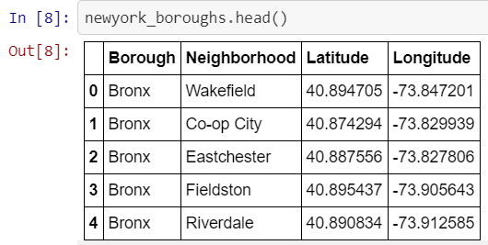

From the map generated with Folium we are able to see all the five boroughs of New York with circle markers on all neighbourhoods.

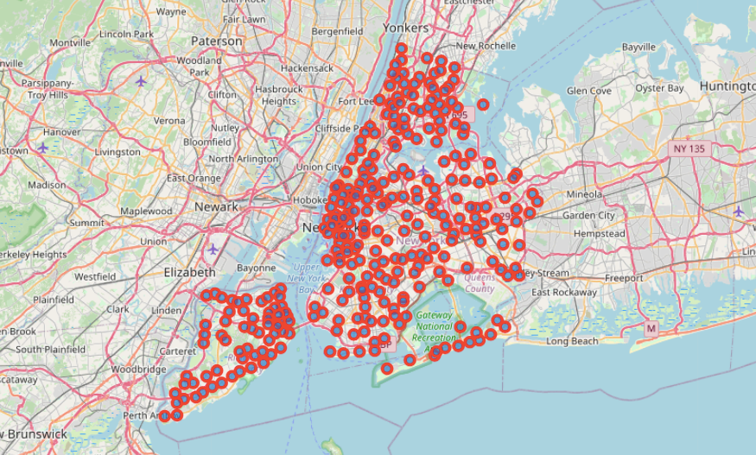

In the Manhattan area where Veronica is staying, we begin to look around the neighbour to see what she can start with within her limited time of stay. We first can find out the first 5 neighbourhoods in Manhattan.

# 

After loading my FourSquare credentials, we are able to fetch relevant information, in other words, information about good-rating Italian restaurants that Veronica can explore soon within radius = 500.

# Analysis

The full code can be viewed here: <https://github.com/qxwu/Coursera_Capstone/blob/master/Battle%20of%20Neighborhoods.ipynb>

# Findings

# Viola! We have found five Italian restaurants near Veronica’s vicinity.

Since Veronica is very tight on time and she doesn’t want to travel far, we have chosen the first one, Quality Italian, as a starting point. The rating of the restaurant turns out not too bad: 8/10.

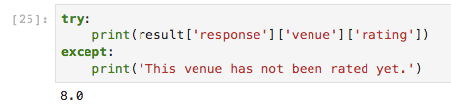

Although another Italian restaurant, Serifina Italian is closer to where Veronica is staying, the venue hasn’t been rated yet so it’s better not to venture within a limited period of stay.

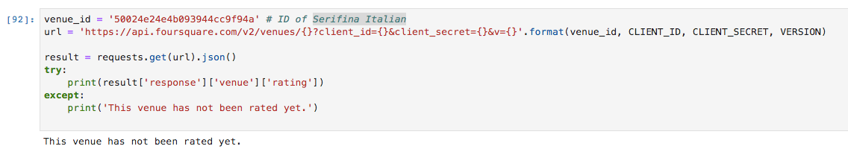

Other areas that Veronica can explore for Italian food when she is back to New York again are Belmont, West Village and Greenwich Village as they are the top places where Italian restaurants boomed. Lenox Hill and Bay Ridge probably are not a good idea for staying as they have the least Italian restaurants around.

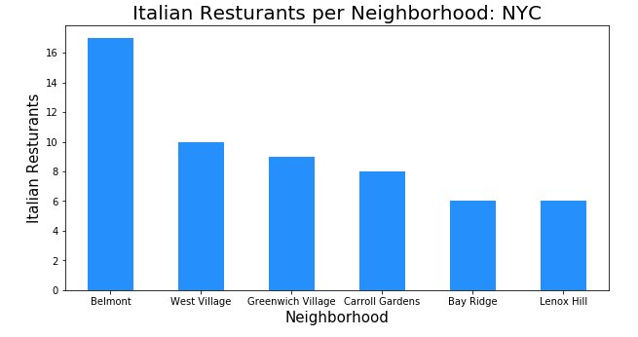

**Conclusion**

* Five Italian restaurants are close to where Veronica is staying.
* Quality Italian has the best rating so Veronica can start exploring it within her time-limited stay.
* Belmont, West Village and Greenwich Village has the most Italian restaurants that Veronica can explore when she has more time on her next trip.

**Limitations**

* The ranking is purely on basis of rating of restaurants and some of the reviews are from a long time ago.
* The accuracy of data depends purely depends on the data provided by FourSquare.